*Florida International University*

*School of Computing and Information Sciences*

CIS 4911 - Senior Capstone Project

Software Engineering Focus

Feature Document

User Story #1079

**Team Member:**

Johnatan Jensen

**Product Owner(s)**:

Mohsen Taheri

**Mentor(s)**:

Mohsen Taheri

**Instructor**: Masoud Sadjadi

**User Story** **Manage users profile**

* As a User, I would like to upload a profile picture and a resume, to make my profile page more interesting and relevant.

Acceptance Criteria

* Embed resume as PDF in the page
* Create Profile page to show other users info, profile photo and resume
* Add functionality to upload resume
* Add functionality to upload profile photo

**Use Case**

1. **As a faculty I would like to see the students information from their projects page**   
   Participating Actors: Faculty  
     
   Entry Condition: The Faculty is browsing a project and wishes to see the information on the students working on the project  
     
   Events Flow:
2. The Faculty clicks on some students name to see more information on them
3. The Faculty is redirected to the specific students profile page
4. The use case ends when the faculty sees the students information and resume if they have one uploaded
5. **As a student I would like to upload my resume and a profile photo for research opportunities with faculty on VIP**   
   Participating Actors: User  
     
   Entry Condition: A user wishes to update their profile to include a profile picture and resume to build a better portfolio if a Faculty decides to look at their profile.   
     
   Events Flow:
6. The user visits their edit profile page
7. The user clicks the “Upload profile picture” button
8. The user selects the profile picture they wish to upload in .jpg .png or .gif format
9. The user clicks the “Upload resume” button
10. The user selects the resume they wish to upload as a .pdf file
11. The user reviews his information
12. The user clicks the “update” button to update their profile
13. The use case ends when the popup confirms their profile is updated

**Use Case Diagram**

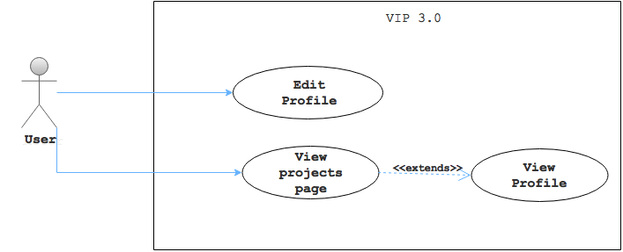

**Sequence Diagram**

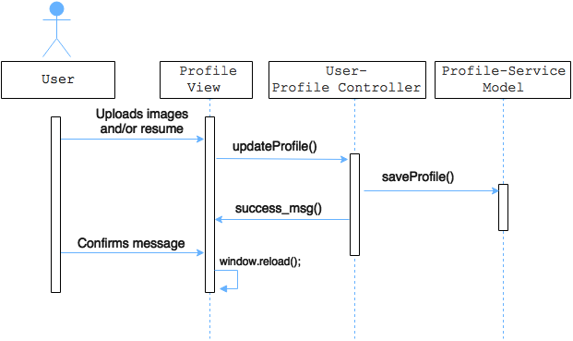

**Class Diagram**

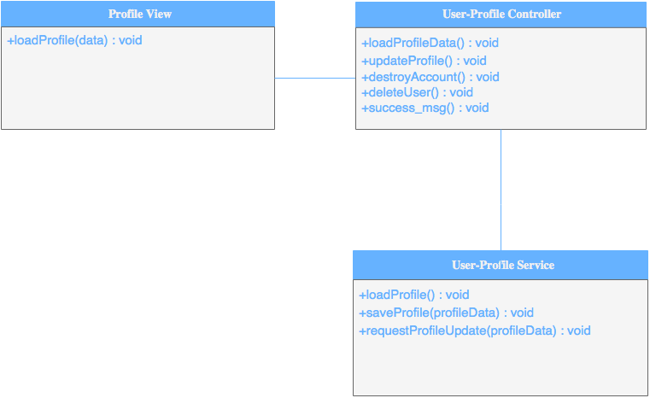

**Unit & Integration Tests**

* **Test Case 1**
  + **Purpose:** Test that each (profile or resume) can be uploaded separately
  + **Precondition:** Uploaded a profile picture or resume and not the other
  + **Expected Result:** It will upload successfully without issue
  + **Actual Result:** As expected
  + **Status: PASSED**
* **Test Case 2 (Rainy)**
  + **Purpose:** Test that non-pdf’s cannot be uploaded to resume
  + **Precondition:** Load a non-pdf file to resume
  + **Expected Result:** Non-pdfs will be rejected with a message
  + **Actual Result:** Non-pdf file types are not clickable and if they are they are given an error message
  + **Status: PASSED**

**Visual User Guide**

**The two new buttons and a slight UI update for the form**

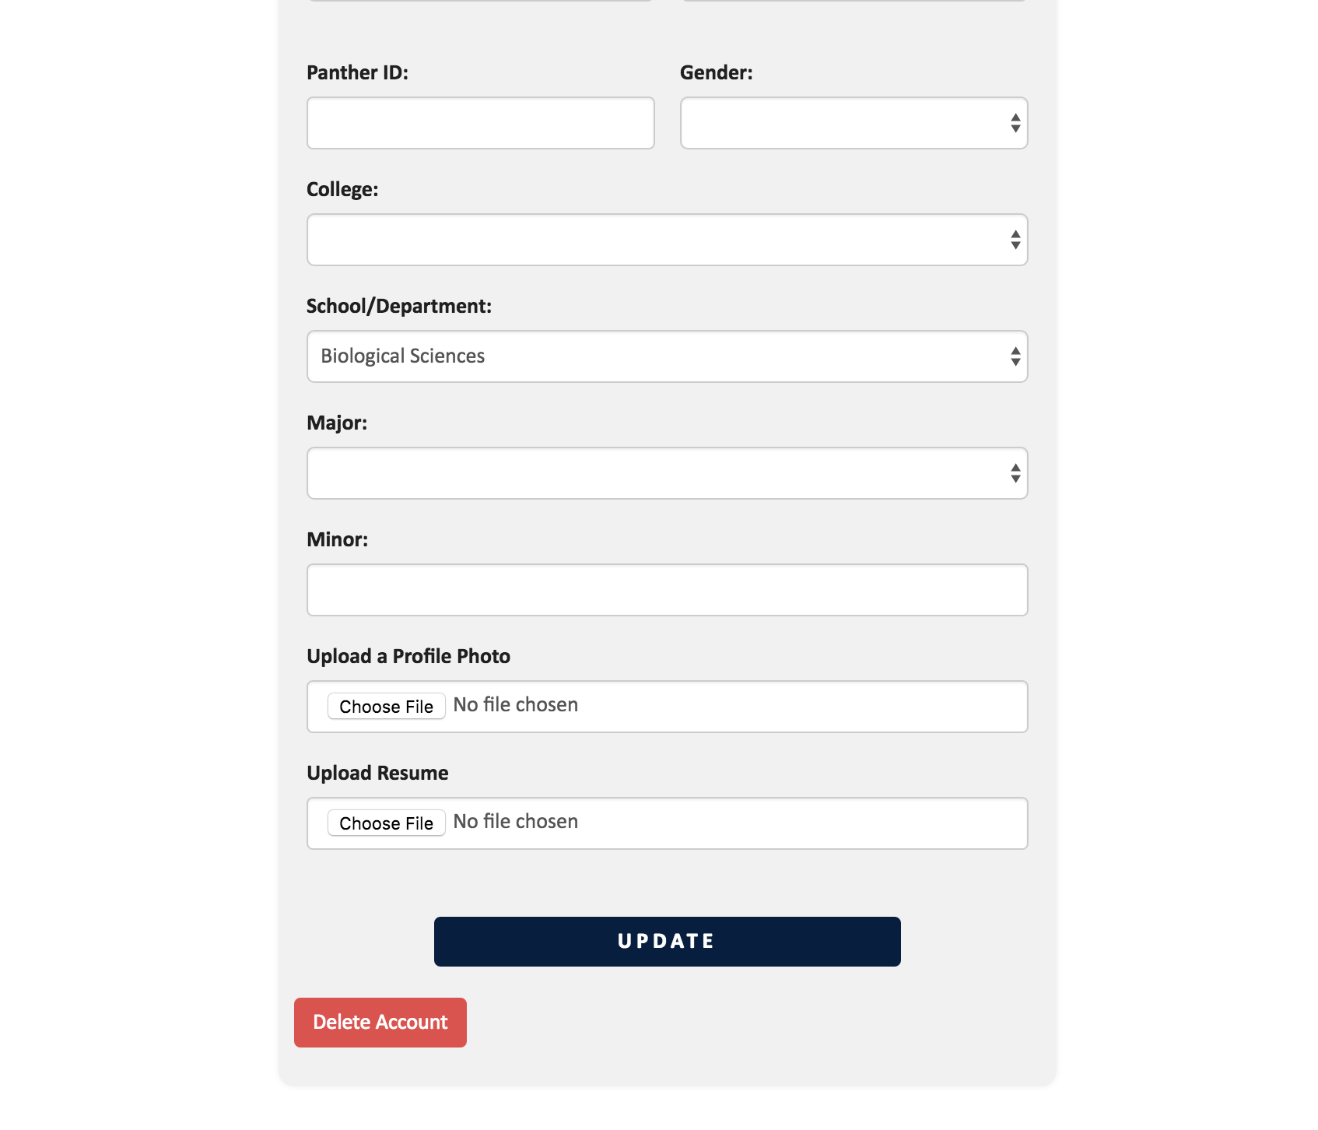

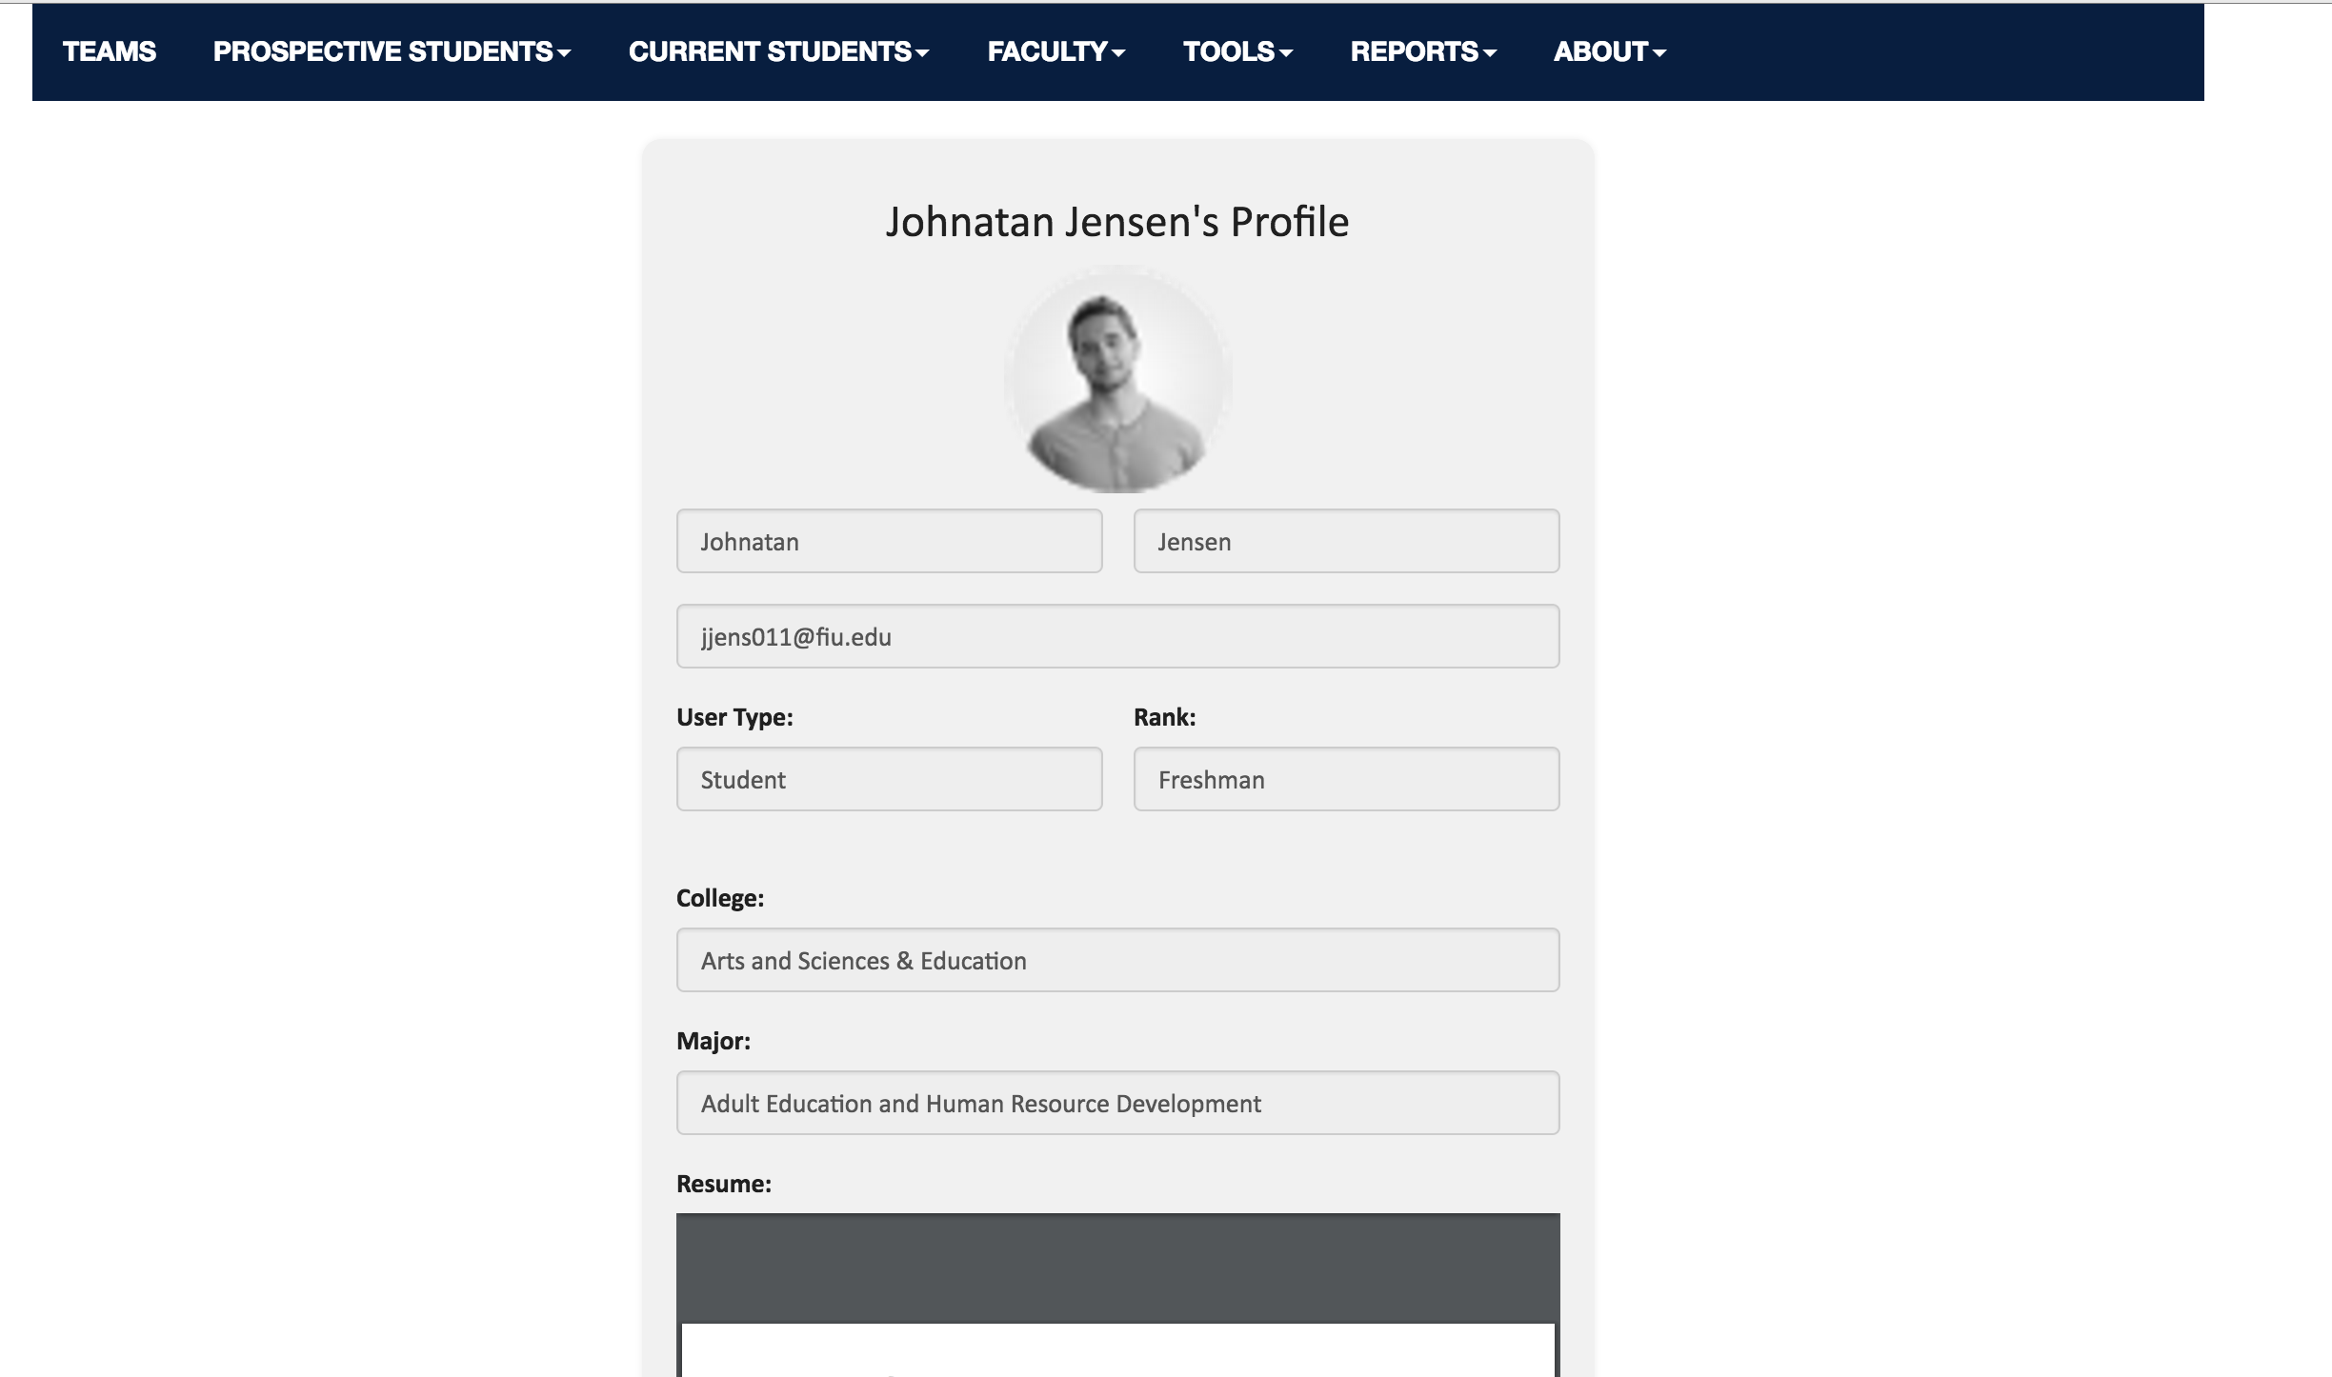

**This is what is seen if the user updates their profile photo and adds a resume. Faculty are now ready to see what students have to offer.**

